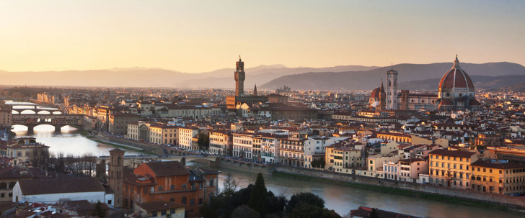

**Florence Art History Class: Masterpieces and Monuments** **with Elaine Ruffolo**

**Winter 2025**

**Course Description:**

The course is intended as an in-depth study of art and architecture of the Italian Renaissance, with a special emphasis on Florence. Each class is devoted to a single topic or decorative complex. All classes are held on-site in a museum, piazza or monument in Florence.

**Thursday, February 6 Friday, February 7**

**Thursday, February 13 Friday, February 14**

**Thursday, February 27 Friday, February 28**

**Class time**:

10:00 am to 1:00 pm

**Contact:**

Elaine’s phone number: 339-215-98-51

Kellin Nelson: 333-184-5328

Email: admin@elaineruffolo.com

**Fees:**

The fee for all six classes is €400. If you choose to participate on a drop-in basis, the cost is €75 per class (please note: this does not include entrance fees). Payment is due at the beginning of class in cash (please try to put in an envelope labeled with your name). You can also pay via Zelle (use email **admin@elaineruffolo.com**. If you pay directly on my website using a [credit card](https://donorbox.org/virtual-art-history-encounters-elaine-ruffolo) please be sure to add 3% (€77 per class or €412 for the entire series).

**Useful information:** You may want to purchase a [PassePartout card](https://www.uffizi.it/en/pages/annual-subscriptions) which is good for entry to the Uffizi, Palazzo Pitti and Boboli Gardens for one year. The pass is €71 and you can get more information [here](https://www.uffizi.it/en/pages/annual-subscriptions). The office is located at the Uffizi and opens at 10am.

**Suggested reading:**

John T. Paoletti Gary M. Radke, Art in Renaissance Italy (5th edition).

Evelyn Welch, Art in Society 1250-1400

Painting and Experience in 15th century Italy, Michael Baxandall, second edition

(Available at the Paperback Exchange on Via delle Oche 2).

**Visits:**

**Thursday, February 6:**

**Sacred and Secular Spaces**

Site visit: San Miniato and Palazzo Vecchio

10:00 am meet at San Miniato al Monte (walk, taxi, or take the number 12 bus)

20 Euro entrance fee

Total class fee: 95 Euro

**Friday, February 7:**

**Renaissance Painting**

Site Visit: Uffizi Gallery

10:00 am meet at door number 1 outside the museum (this class is limited to 15 participants)

25 Euro entrance fee or Uffizi pass

Total class fee: 100 euro

***You can book the Vasari Corridor online for 43 euros (20 euros if you have a passepartout) which includes the Uffizi entrance. Book a 1:00pm or after Vasari Corridor entrance

https://www.uffizi.it/en/corridoio-vasariano****

**Thursday, February 13:**

**The Oltrarno**

Site visit: The Oltrarno: Santa Felicita, Santo Spirito, Santa Maria delle Carmine

Meet on the Ponte Vecchio at the statue of Cellini.

Entrance fee: 10.00 Euro Santa Maria delle Carmine and 4.00 euro at Santo Spirito

Total class fee 90 Euros

**Friday, February 14:**

**Michelangelo**

Site visit: Accademia and Laurentian Library

10:00 am meet at the Accademia Galleries on via Ricasoli

20 Euro entrance fee Accademia, 8 Euro entrance fee Laurentian Library

Total class fee: 105 euro

**Thursday, February 27:**

**Cathedral Complex**

Site Visit: Cathedral of Florence, Museo dell’ Opera del Duomo, and Baptistry

10:00 am Meet on the steps of the Cathedral

20 Euro entrance fees

Total class fee: 95 euro

**Thursday February 28: Magnificenza: Palazzo Pitti**

Site Visit: Palazzo Pitti and Medici Treasures.

10:00 am meet in front of the Palazzo Pitti.

16 Euro entrance or use your Uffizi/Pitti pass

Total class fee: 90 euro

**Field trip: Assisi March 14**

Cost: 220 euros (based on 15 participants)

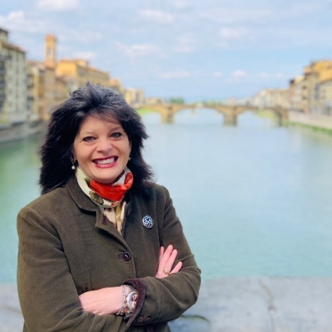Elaine Ruffolo has been making Renaissance art come alive for students and travelers for over 30 years. Known for her engaging teaching style, she’s passionate about exploring how the politics, economy, and personalities of the 15th century shaped the incredible art of the period. Elaine believes you can’t fully appreciate a painting or sculpture without understanding the world it was created in—and she’s a pro at bringing that world to life.

Beyond her academic contributions, Elaine is an advisory board member for the Friends of Florence and president of Events in Italy, where she curates cultural travel programs for international audiences. Since 2020, she has expanded her reach through Art History Encounters, an online platform bringing Renaissance art and culture to global audiences. Elaine’s dedication to making art history both accessible and relevant continues to inspire learners worldwide.